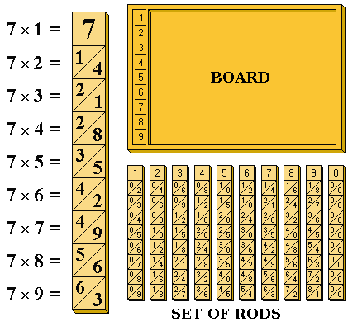

Napier's rods
Napier's bones, also called Napier's rods, are numbered rods which can be used to perform multiplication of any number by a number 2-9. By placing "bones" corresponding to the multiplier on the left side and the bones corresponding to the digits of themultiplicand next to it to the right, and product can be read off simply by adding pairs of numbers (with appropriate carries as needed) in the row determined by the multiplier. This process was published by Napier in 1617 an a book titled Rabdologia, so the process is also called rabdology.

.
