P I C K'S T H E O R E M

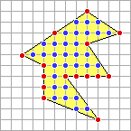
Pick's theorem provides an elegant formula for the area of a simple lattice polygon: a lattice polygon whose boundary consists of a sequence of connected nonintersecting straight-line segments. The formula is

$$\text{Area}=I+\frac{B}{2}−1$$
Where
I = number of interior lattice points
B = number of boundary lattice points
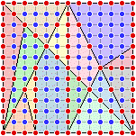
For example, the area of the simple lattice polygon in the figure is
31 + 15 /2 - 1 = 37.5
The interior and boundary lattice points of the fourteen pieces of the Stomachion are indicated on the left. Using Pick's theorem the areas of the fourteen pieces can be determined as in the above example; e.g., the blue piece in the upper right-hand corner has area
18 + 14 /2 - 1 = 24

